**Fundamentals of Computer Programming**

**Building a Programming Portfolio**

**Week 6**

You should be able to complete the following programs by the end of the week. You should keep the code somewhere safe, in an organised way. GitHub is ideal. Wherever you choose, you should ensure that the work is safe and backed up.

Possible solutions will be uploaded to the main module GitHub repository every week. If you follow that repo you should be able to receive notifications.

1. Write a function that accepts a positive integer as a parameter and then returns a representation of that number in binary (base 2). Hint: This is in many ways a trick question. Think!

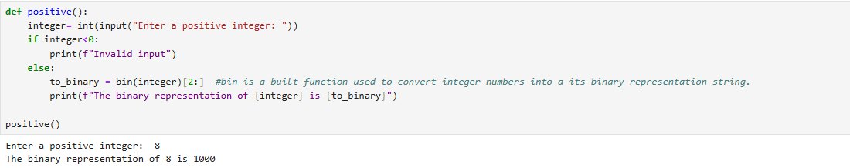

1. Write and test a function that takes an integer as its parameter and returns the factors of that integer. (A factor is an integer which can be multiplied by another to yield the original).

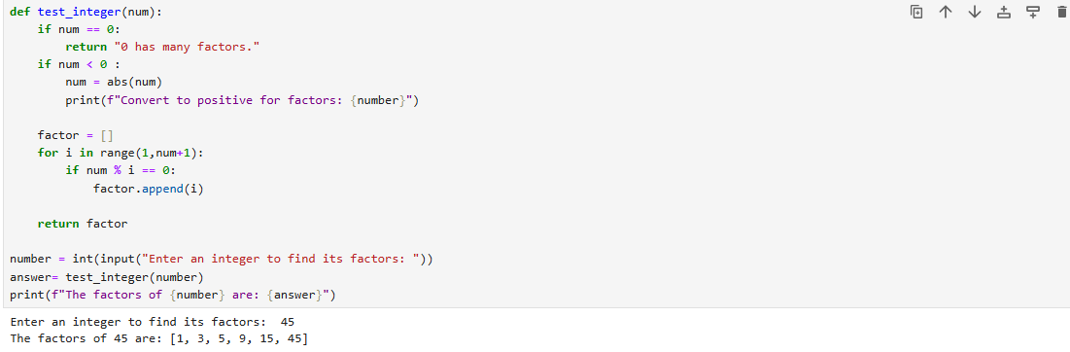

1. Write and test a function that determines if a given integer is a prime number. A prime number is an integer greater than 1 that cannot be produced by multiplying two other integers.

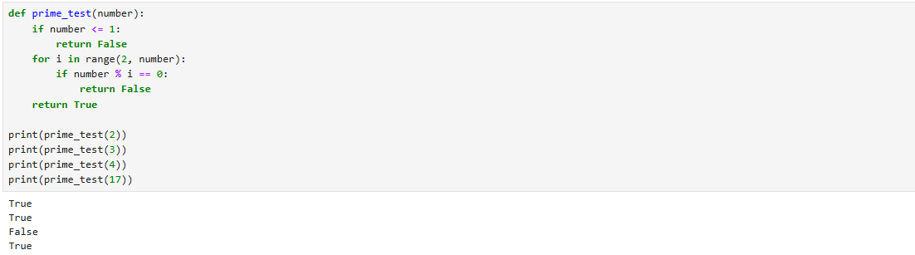

1. Computers are commonly used in encryption. A very simple form of encryption (more accurately "obfuscation") would be to remove the spaces from a message and reverse the resulting string. Write, and test, a function that takes a string containing a message and "encrypts" it in this way.

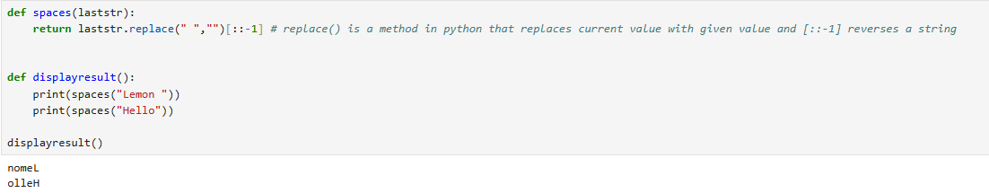

1. Another way to hide a message is to include the letters that make it up within seemingly random text. The letters of the message might be every fih character, for example. Write and test a function that does such encryption. It should randomly generate an interval (between 2 and 20), space the message out accordingly, and should fill the gaps with random letters. The function should return the encrypted message and the interval used.

For example, if the message is "send cheese", the random interval is 2, and for clarity the random letters are not random:

send cheese

s e n d c h e e s e

sxyexynxydxy cxyhxyexyexysxye

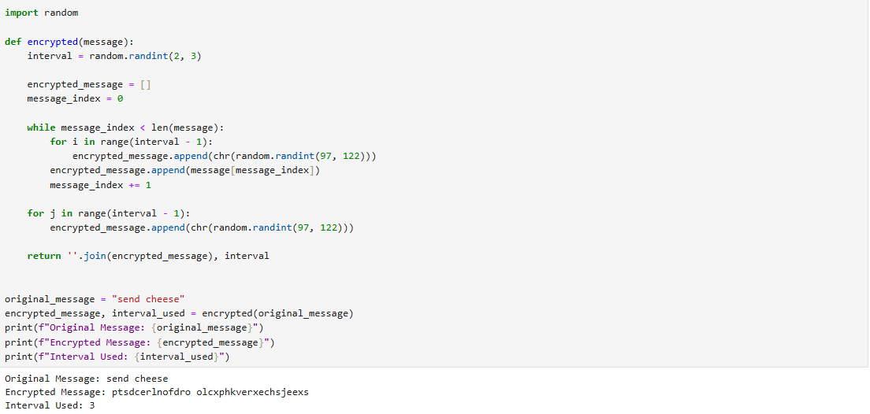

1. Write a program that decrypts messages encoded as above.

sxyexynxydxy cxyhxyexyexysxye

sendcheese

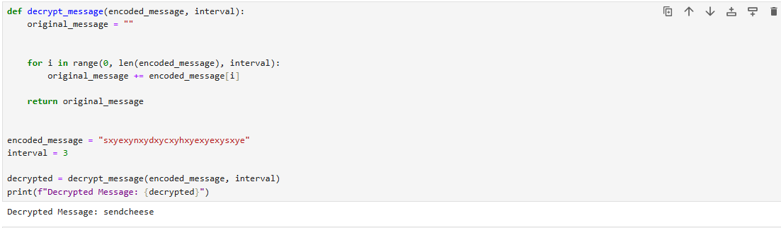

Programming Portfolio 06 V1.0 2022-08-12 AMJ